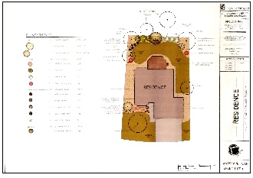
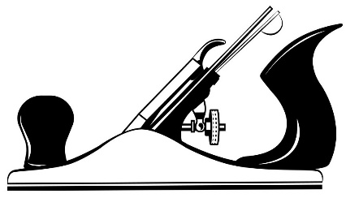
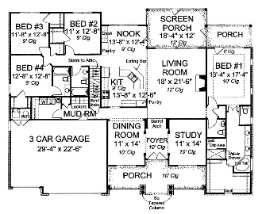

Lesson Plans for Building Trades & Wood Shop classes:
(Click on the link to each class below)

Middle School Periods 1 & 7 - Intro to Building Technology

High School Period 03 - Intro to Architecture and Design
Period 04 - Cabinetry
Periods 5 & 6 - Intro to Building Trades

Link to Plan Book for all classes

